Practicum Final Exam – Example Case
Subject |  |  | COMP6048 – Data Structures  COMP6048001 – Data Structures  COMP6048016 – Data Structures  COMP6048049 – Data Structures |  |  | 
Class | : | - |  | Start Date | : -
Lecturer | : | - |  | Start Time | : -
 |  |  |  | End Date | : -
 |  |  |  | End Time | : -

Soal
Case
Sally Salon
Sally Salon is an application used to manage customer data using old technology. Recently, the owner of Sally Salon, Ms. Suki, decides to hire you to help her build a faster, more reliable application using AVL Tree as its algorithm. You are to create an application based on the following requirements.
- At the start of the program, there will be 4 menus, which consists of:
- View Available Treatment
- Insert New Treatment
- Delete Treatment
- Exit
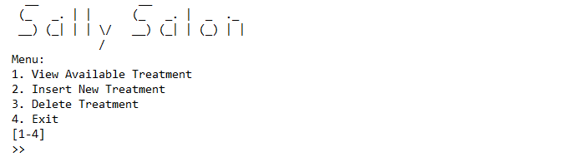
Figure 1. Main Menu
- If user choose menu 1 (“View Available Treatment”), the program will:
- Check data from AVL Tree. If there are no data, display following message.
Figure 2. No Data Message
- Otherwise:
- Prompt user to input view order. Validate the input must be between “pre”, “in”, and “post” (case sensitive).
Figure 3. View Input Prompt

- If view order is “pre”, display all data in pre-order format.
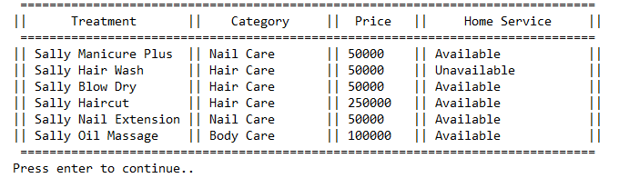
Figure 4. View Data in Pre-Order Format
- If view order is “in”, display all data in in-order format.
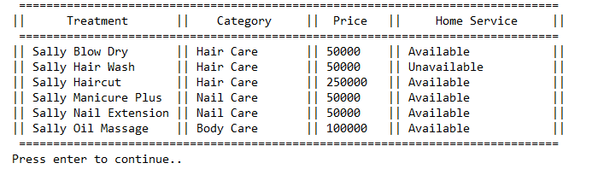
Figure 5. View Data in In-Order Format
- If view order is “post”, display all data in post-order format.
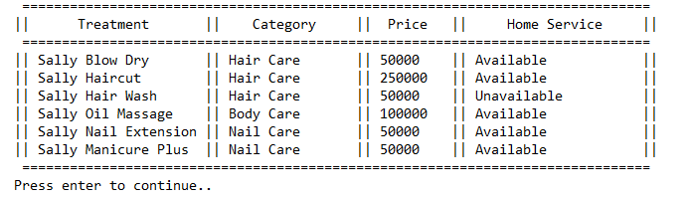
Figure 6. View Data in Post-Order Format

- If user choose menu 2 (“Insert New Treatment”), the program will:
- Prompt user to input treatment name. Validate the input based on the following conditions:
- Input must starts with “Sally”.
- Input must be between 5 and 20 characters (inclusive).
- Input must contains 2 words at minimum.
- Prompt user to input treatment price. Validate the input must be between 50000 and 1000000.
- Prompt user to input treatment category. Validate the input must be between “Hair Care”, “Nail Care”, and “Body Care” (case sensitive).
- Prompt user to input treatment availability. Validate the input must be between “Available” and “Unavailable” (case sensitive).
- Finally, push all data unto the AVL Tree with treatment name as its key.
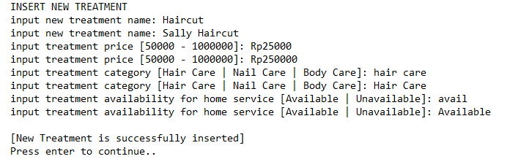
Figure 7. Insert Treatment Data Input
- If user choose menu 3 (“Delete Treatment”), the program will :
- Check data from AVL Tree. If there are no data, display following message.
Figure 8. No Data Message
- Otherwise:
- Display all data in in-order format.
- Prompt user to input treatment name.
Figure 9. Delete Input

- Check data from AVL Tree based on input. If data not exists, display following message.
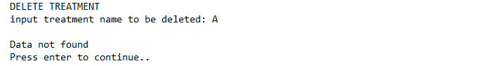
Figure 10. Searched Data Not Exists
- Otherwise, remove corresponding data from AVL Tree and display following message.
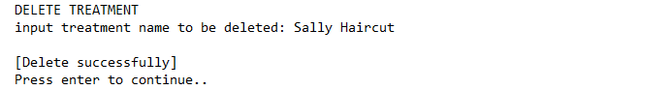
Figure 11. Successfully Delete Data Message
- If user choose menu 4 (“Exit”), the program will close.

